LAB PROGRAMS

UNIT-1

**Done by:**

Prajiith K

192324013

B.Tech AI & DS

1. Perform the following mathematical operations in R: addition, subtraction, multiplication, division, and exponentiation with two numbers

(e.g., 8 and 2).

**PROGRAM CODE**:

v = 8

t = 2

cat("Addition: ",v+t,"\n")

cat("Subraction: ",v-t,"\n")

cat("Multiplication: ",v*t,"\n")

cat("Division: ",v/t,"\n")

cat("Exponent: ",v^t)

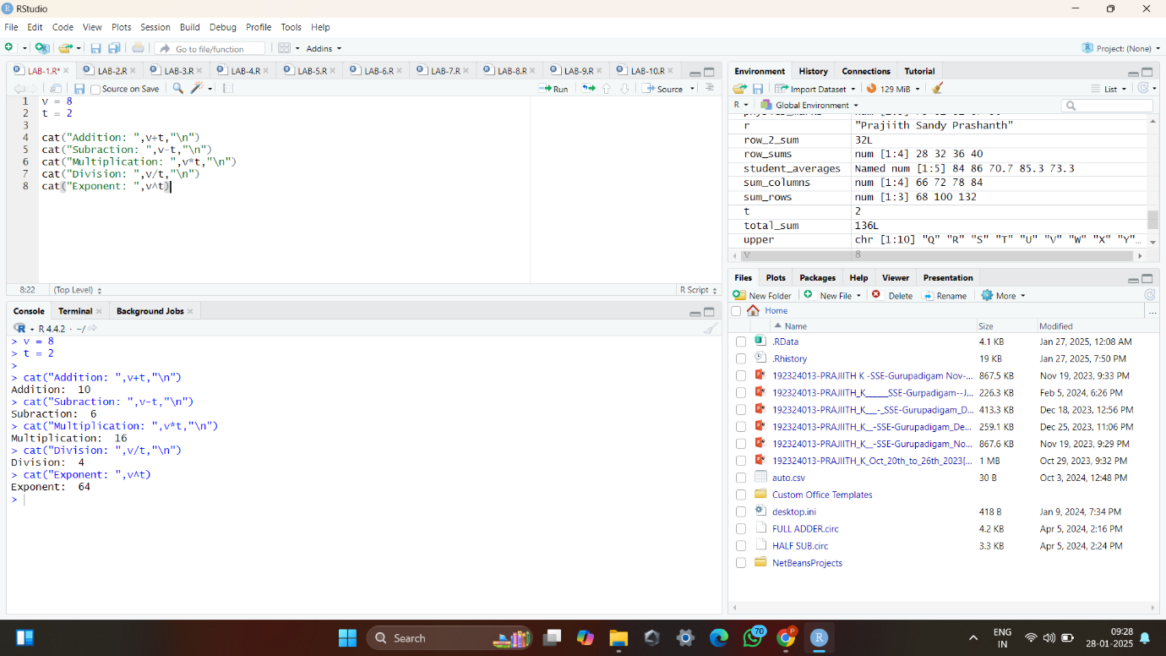

2. Write an R script to create a data frame with employee details (ID, Name, Age, Salary). Perform operations to add a new column, filter rows based on a condition, and sort the data frame by salary.

**PROGRAM CODE**:

employee_details <- data.frame(id=c(1,2,3,4),

name=c("Prajiith","Sandy","Prashanth","Mano"),

age=c(18L,19L,18L,18),

salary=c(100000.80,80000,90000,75000))

print("Before adding new column:\n")

print(employee_details)

print("\nAfter adding new column\n")

employee_details$job <- c("CEO","WORKER","EMPLOYEE","SALESMAN")

print(employee_details)

print("\nFiltered rows based on a condition:\n")

filtered <- subset(employee_details,salary>75000)

print(filtered)

print("\nSorted employee details based on a column:\n")

sorted_employee_details <- employee_details[order(employee_details$salary),]

print(sorted_employee_details)

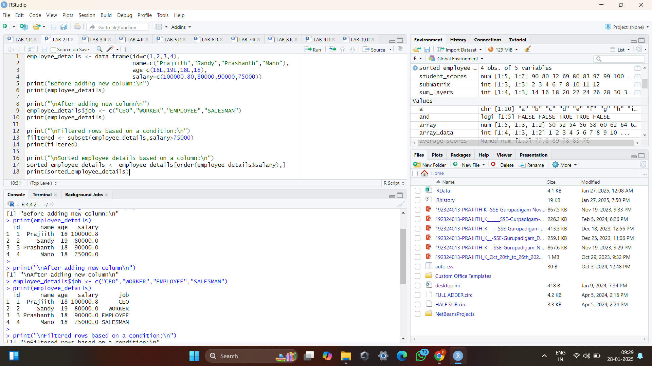

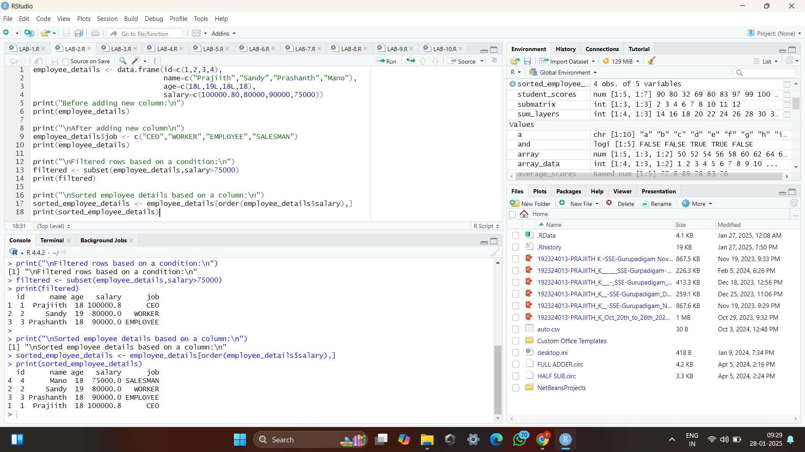

3. Write an R script to perform operations such as slicing, reshaping, and calculating the sum of elements along different dimensions.

**PROGRAM CODE**:

matrix_data <- matrix(1:16, nrow = 4, ncol = 4)

print(matrix_data)

submatrix <- matrix_data[2:4, 1:3]

print(submatrix)

reshaped_matrix <- matrix(as.vector(matrix_data), nrow = 2, ncol = 8)

print(reshaped_matrix)

total_sum <- sum(matrix_data)

print(total_sum)

row_sums <- rowSums(matrix_data)

print(row_sums)

column_sums <- colSums(matrix_data)

print(column_sums)

row_2_sum <- sum(matrix_data[2, ])

print(row_2_sum)

column_3_sum <- sum(matrix_data[, 3])

print(column_3_sum)

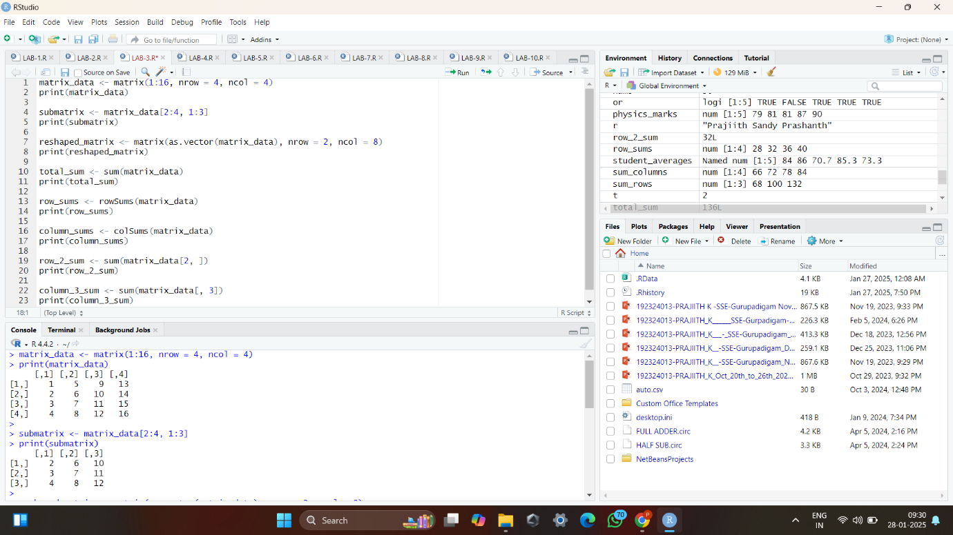

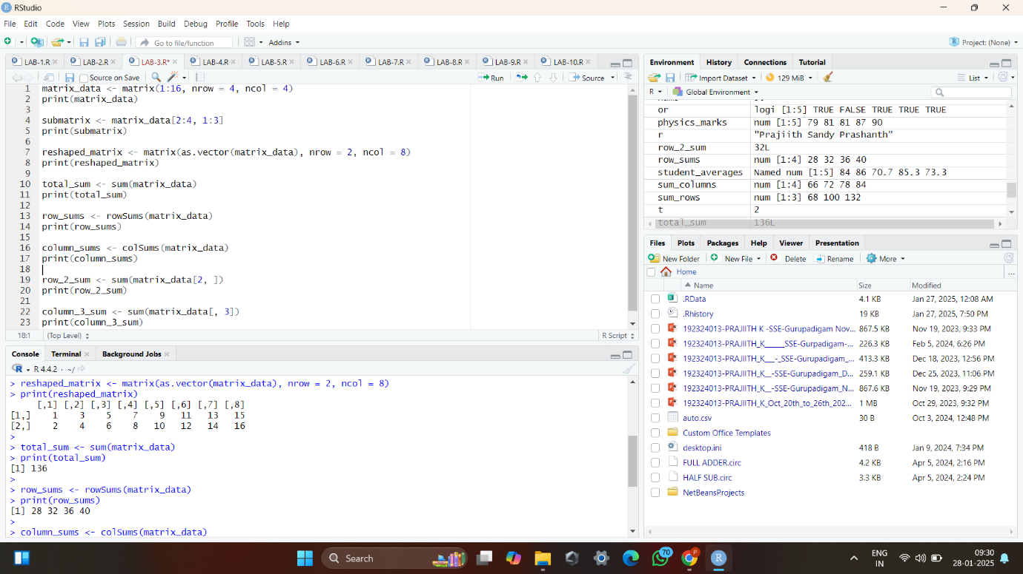

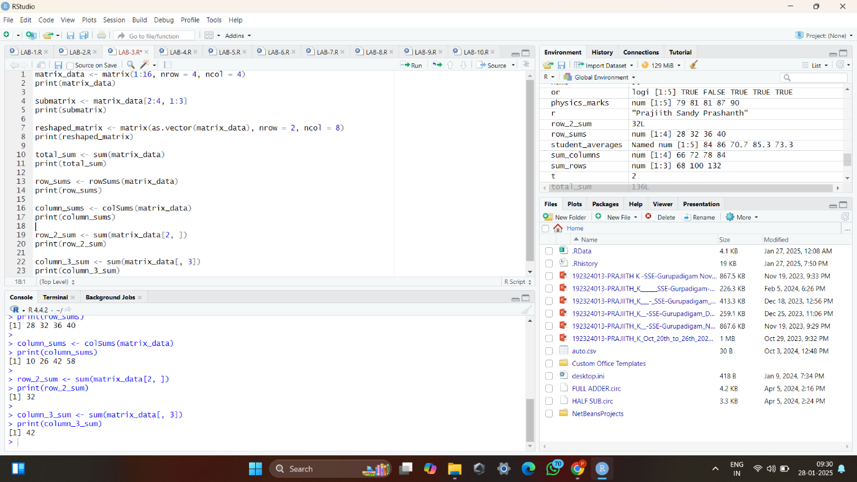

4. Write an R program to create a sequence of numbers from 20 to 50 and find the mean of numbers from 20 to 60 and the sum of numbers from 51 to 91.

**PROGRAM CODE**:

print("Creating a series of number from 20 to 50:\n")

print(20:50)

print("\nThe mean value between 20 and 60:\n")

print(mean(20:60))

print("\nTotal sum of the numbers between 51 and 91:\n")

print(sum(51:91))

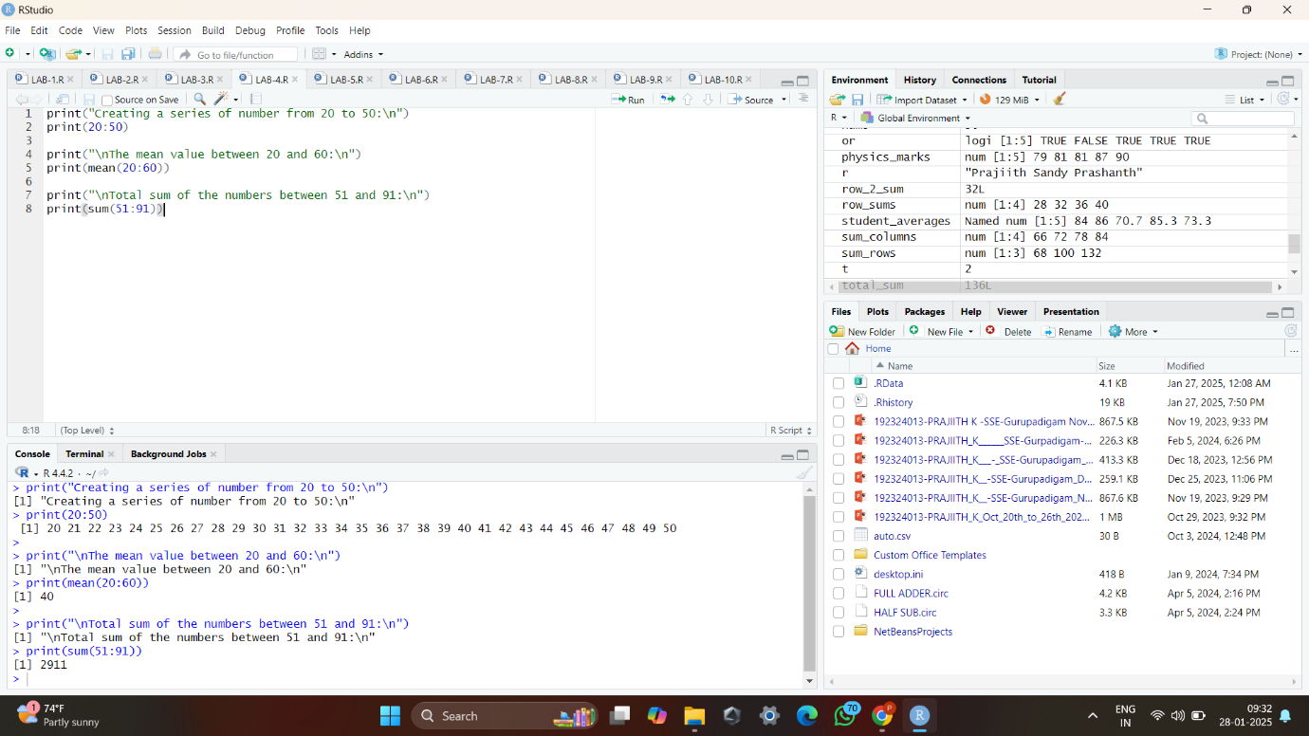

5. Write an R program to extract the first 10 English letters in lower case and the last 10 letters in upper case and extract letters between the 22nd to 24th letters in upper case.

**PROGRAM CODE**:

lower <- head(letters,10)

print("First 10 Lower Alphabets\n")

print(lower)

upper <- tail(LETTERS,10)

print("\nLast 10 Upper Alphabets\n")

print(upper)

btw <- LETTERS[22:24]

print("\nCharacters between 22 and 24\n")

print(btw)

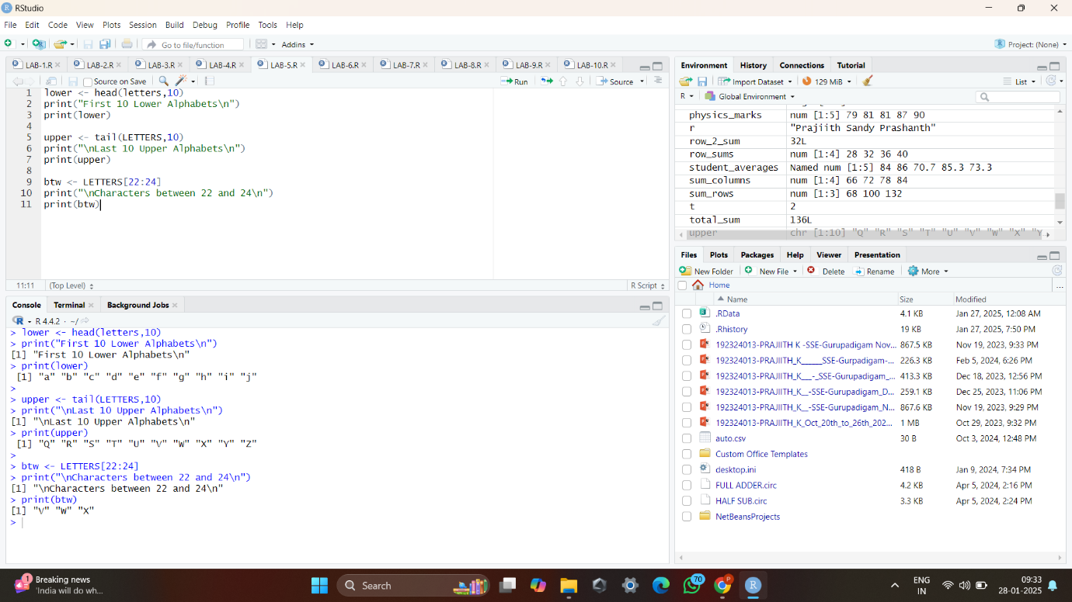

6. Create a logical vector in R Script based on conditions applied to a numeric vector. Use logical operations (AND, OR, NOT) to perform complex filtering on the vector.

**PROGRAM CODE**:

v <- c(5,90,40,30,20)

and <- (v<50) & (v>20)

num1 <- v[and]

cat("Filtering performed through and opeartor: ",num1,"\n")

or <- (v>100)|(v<50)

num2 <- v[or]

cat("\nFiltering performed through or opeartor: ",num2,"\n")

not <- !(v<50)

num3<- v[not]

cat("\nFiltering performed through not opeartor: ",num3)

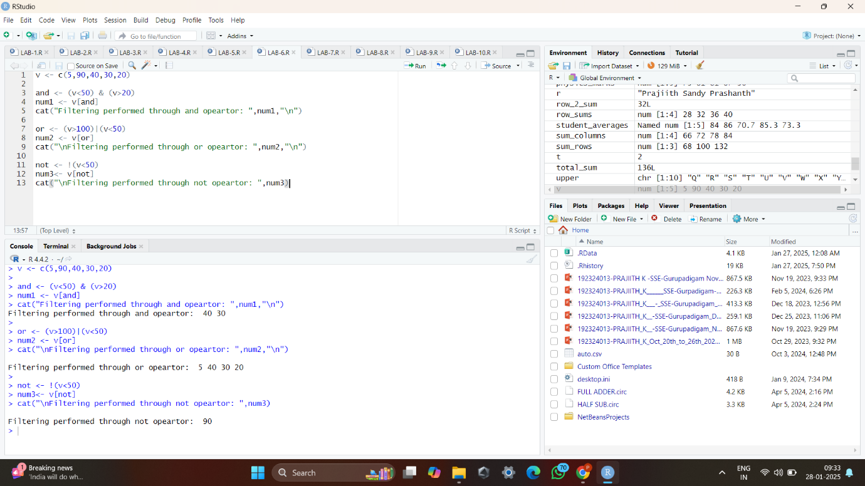

7. Create a factor in R Script from a character vector of categorical data (e.g., colors). Explain the significance of factors in statistical analysis and demonstrate how to change the levels of a factor.

**PROGRAM CODE**:

fruits <- c("Apple","Banana","Orange","Carrot","Apple","Banana","Orange","Carrot")

fruits_factors <- factor(fruits)

print(fruits_factors)

cat("Before modifying factors: ",levels(fruits_factors))

levels(fruits_factors)<- c("Red","Yellow","Orange","Saffron")

print(levels(fruits_factors))

print(fruits_factors)

cat("After modifying factors: ",levels(fruits_factors))

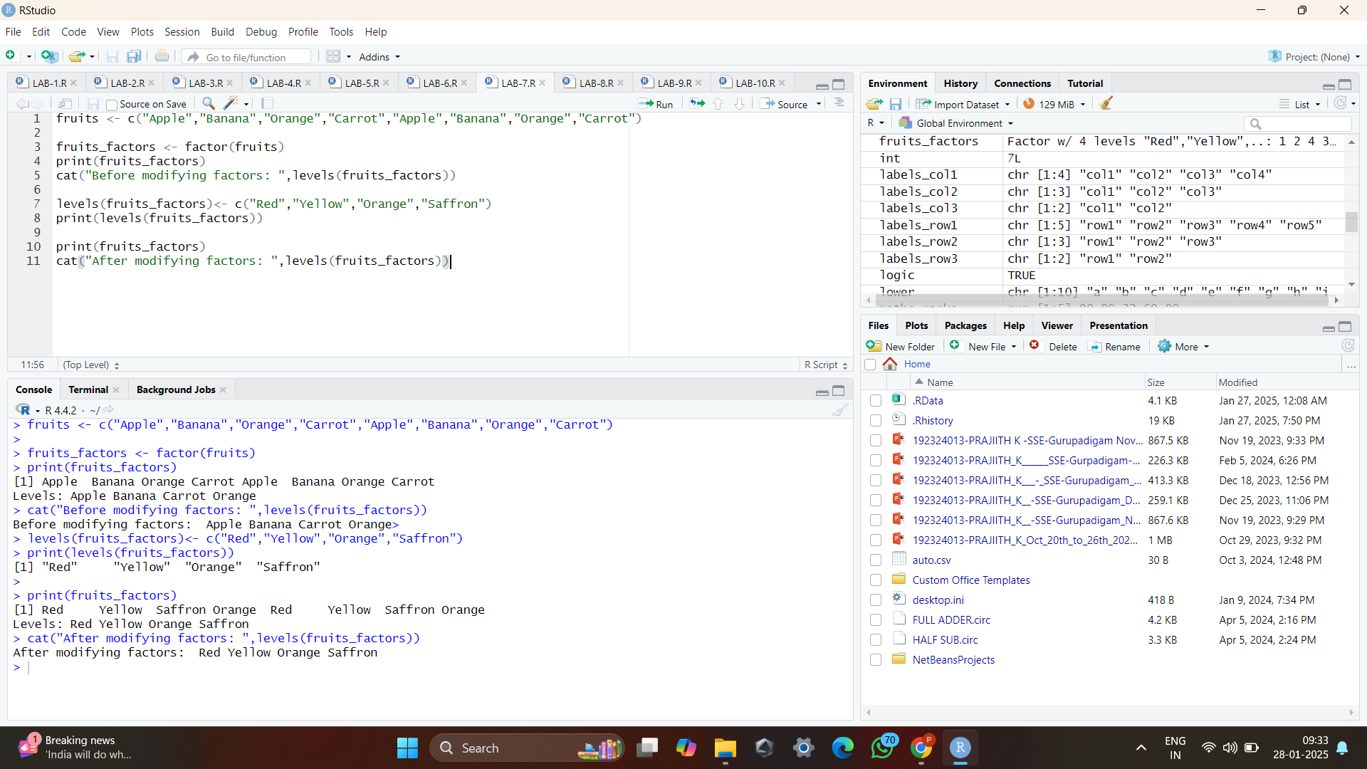

8. Discuss the various data types in R (numeric, integer, character, logical, complex). Provide examples of each and write a script to demonstrate type conversion between them.

**PROGRAM CODE**:

num <- 12.34

cat("Value: ",num,"\nData Type: ",class(num),"\n")

int <- 7L

cat("Value: ",int,"\nData Type: ",class(int),"\n")

char <- "Hello, Prajiith!"

cat("Value: ",char,"\nData Type: ",class(char),"\n")

logic <- TRUE

cat("Value: ",logic,"\nData Type: ",class(logic),"\n")

comp <- 4 + 5i

cat("Value: ",comp,"\nData Type: ",class(comp),"\n")

cat("Numeric to Integer:", as.integer(num), "\n")

cat("Character to Numeric:", as.numeric("45.67"), "\n")

cat("Logical to Numeric:", as.numeric(logic), "\n")

cat("Numeric to Logical:", as.logical(0), "\n")

cat("Complex to Character:", as.character(comp), "\n")

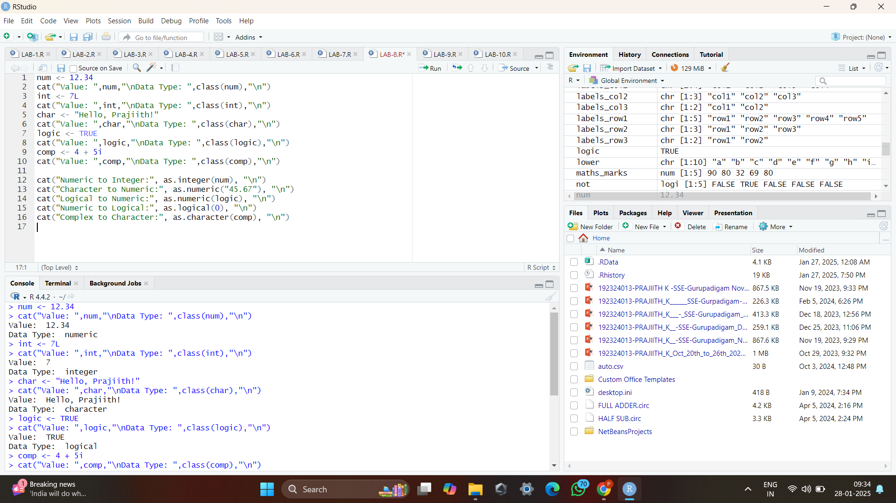

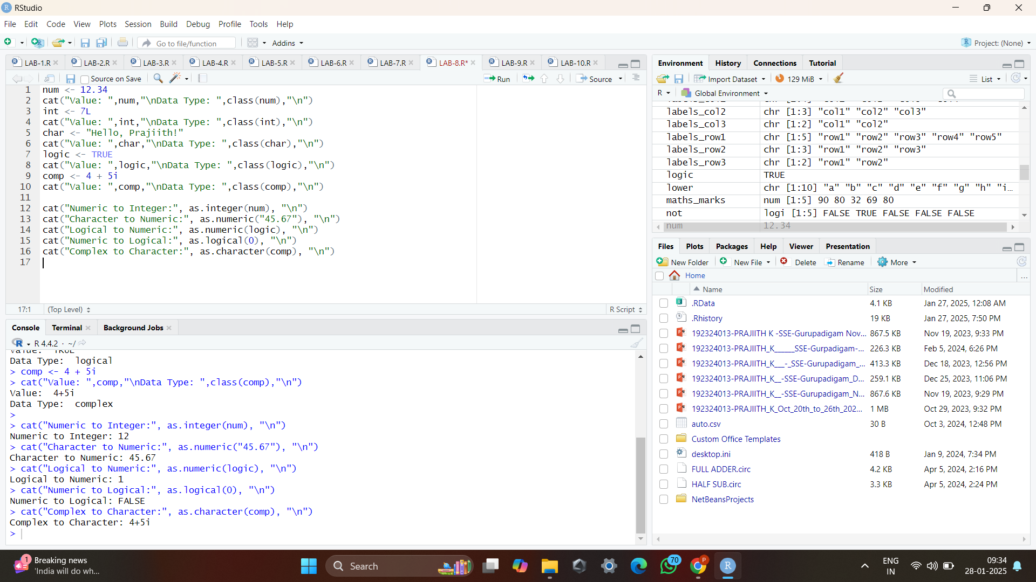

9. Write an R program to create a 5 x 4 matrix, a 3 x 3 matrix with labels and fill the matrix by rows, and a 2 × 2 matrix with labels and fill the matrix by columns.

**PROGRAM CODE**:

labels_row1 <- c("row1","row2","row3","row4","row5")

labels_col1 <- c("col1","col2","col3","col4")

matrix_1 <- matrix(c(1,2,3,4,5,6,7,8,9,1,2,3,4,5,6,7,8,9,1,2),nrow=5,byrow=TRUE,dimnames=list(labels_row1,labels_col1))

print(matrix_1)

labels_row2 <- c("row1","row2","row3")

labels_col2 <- c("col1","col2","col3")

matrix_2 <- matrix(c(1,2,3,4,5,6,7,8,9),nrow=3,byrow=TRUE,dimnames=list(labels_row2,labels_col2))

print(matrix_2)

labels_row3 <- c("row1","row2")

labels_col3 <- c("col1","col2")

matrix_3 <- matrix(c(1,2,3,4),ncol=2,byrow=TRUE,dimnames=list(labels_row3,labels_col3))

print(matrix_3)

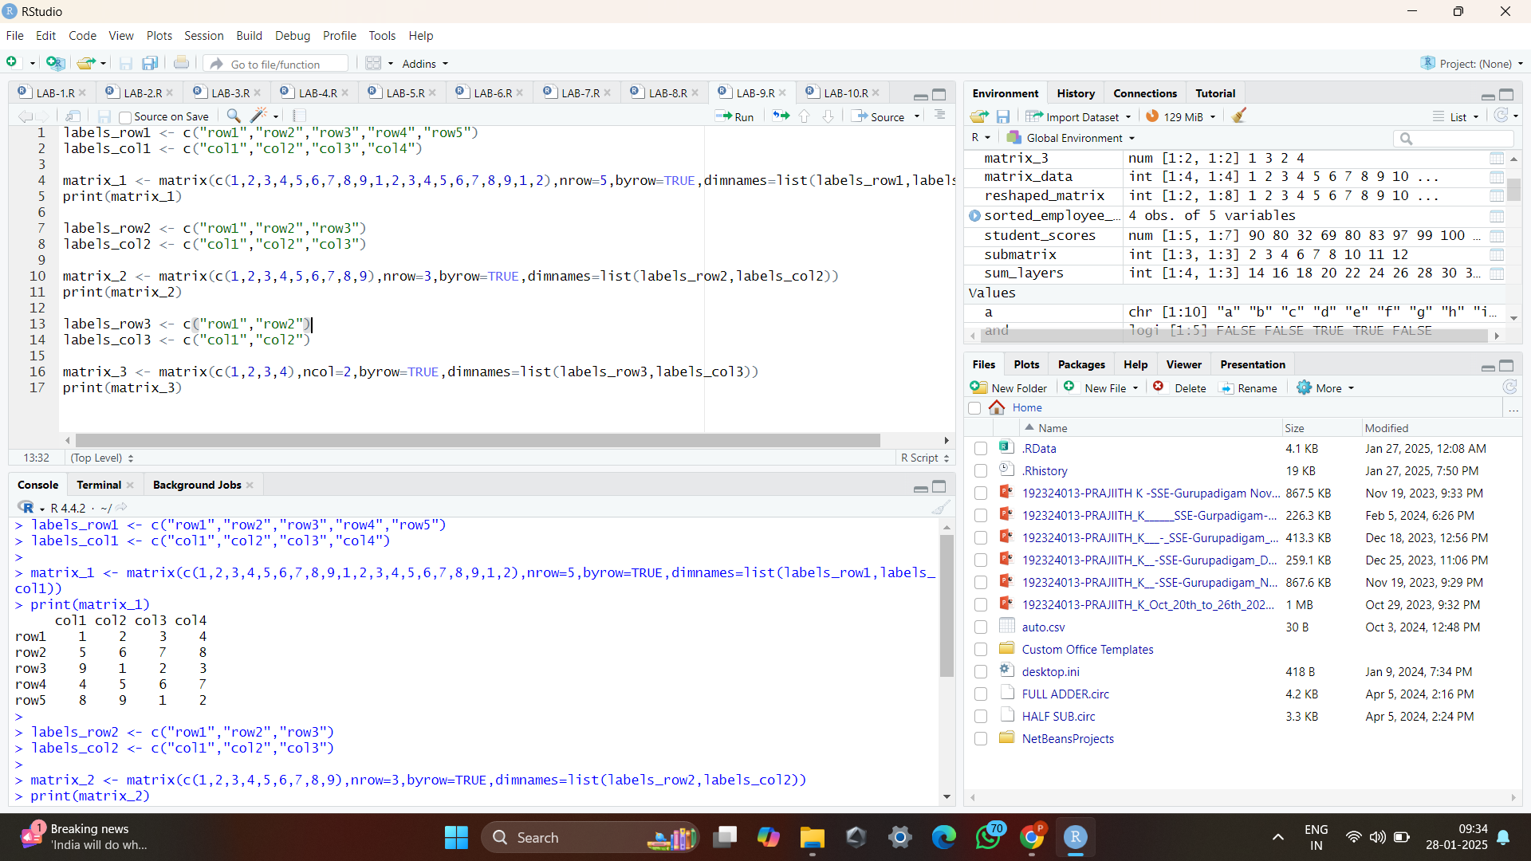

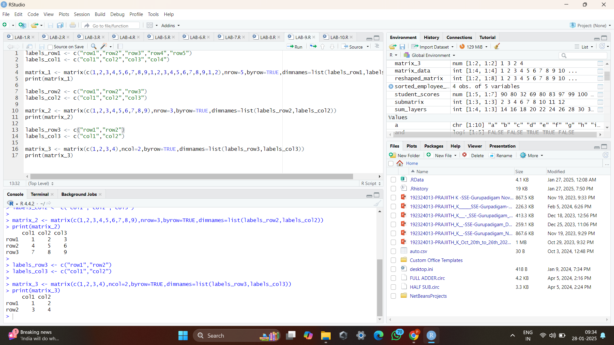

10. Write an R program to create a two-dimensional 5x3 array of sequences of even integers greater than 50.

**PROGRAM CODE**:

even_integers <- seq(from=50,by=2,length.out=15)

print(even_integers)

array <-array(even_integers,c(5,3,2))

print(array)

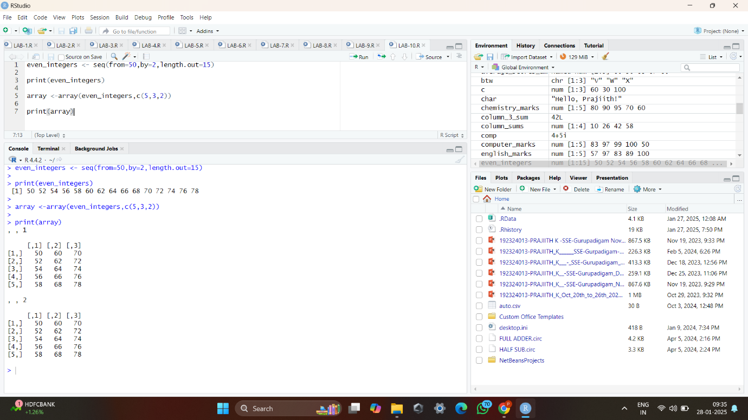

11. Write an R Program to Access Values in a Vector. Print the vector.

**PROGRAM CODE**:

v <- c(100,90,30,50,60)

c <- v[c(5,3,1)]

print(c)

t <- v[c(TRUE,FALSE,TRUE,FALSE,TRUE)]

print(t)

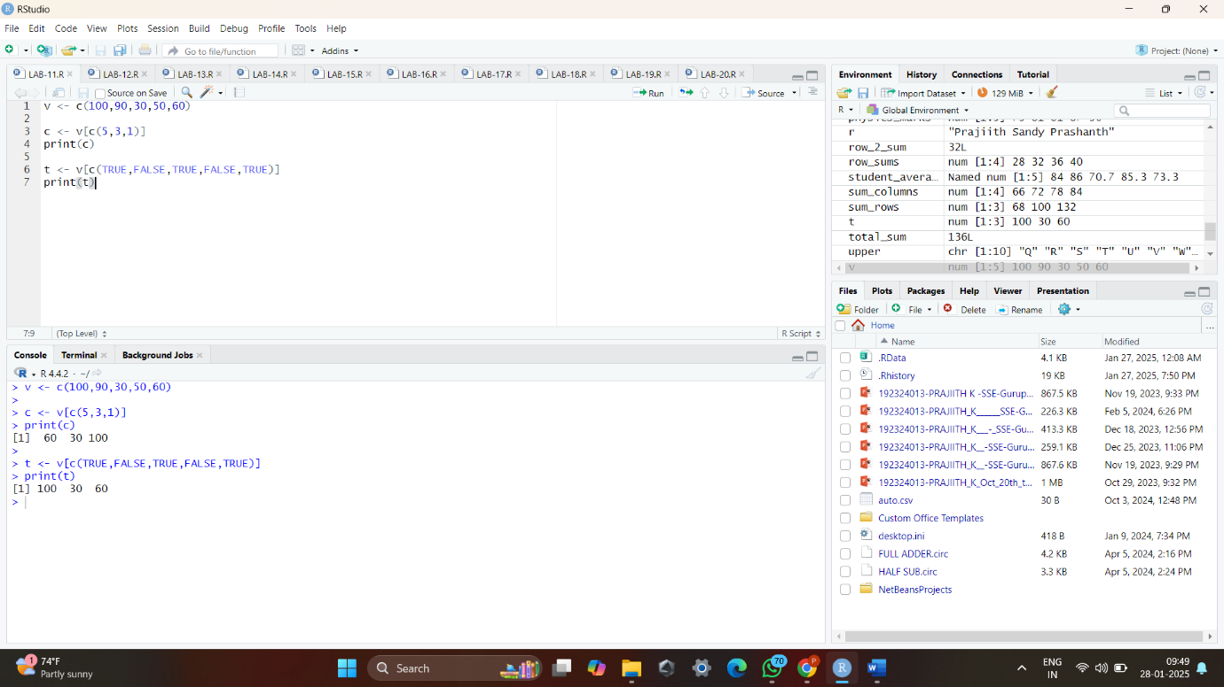

12. Write an R Program to find Nth smallest value in vector .

**PROGRAM CODE**:

n=3

v <- c(7,14,27,26,30,24,6)

sorted <- sort(v)

nth_smallest_number <- sorted[n]

print(nth_smallest_number)

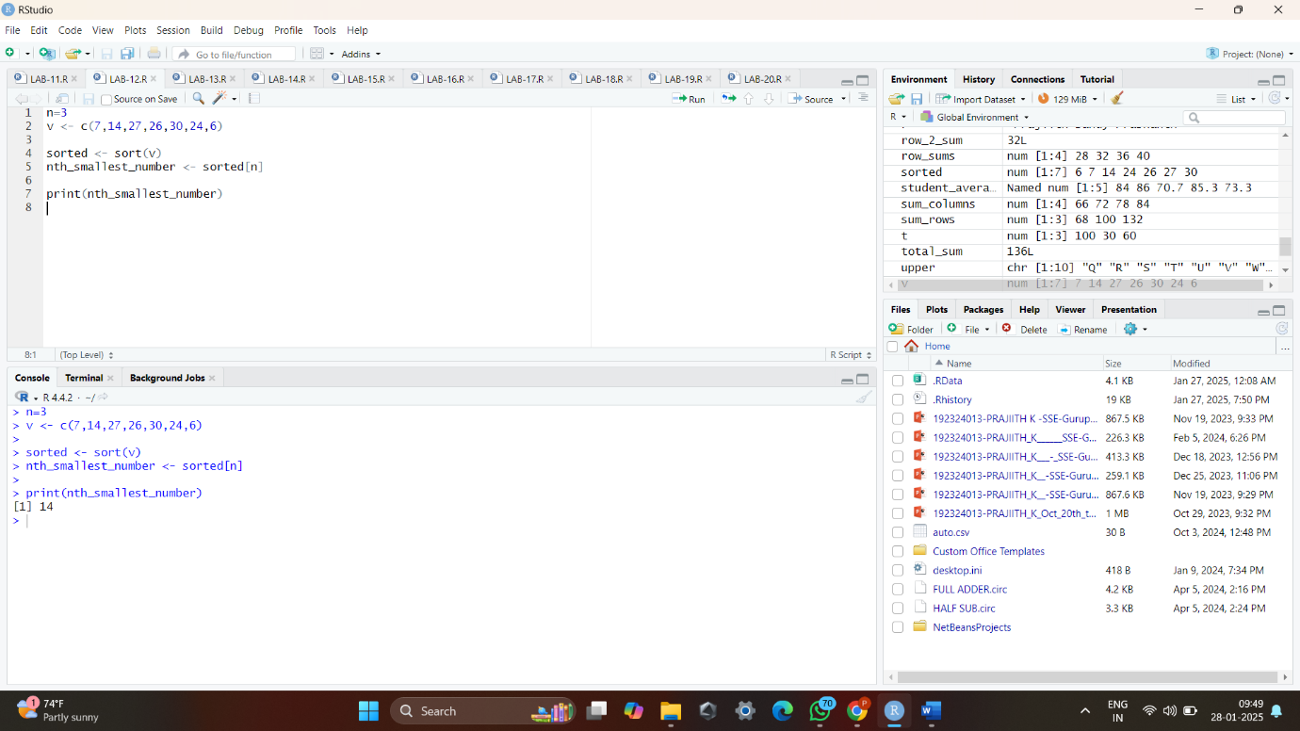

13. Write an R Program to Concatenate a Vector of Strings.

**PROGRAM CODE**:

v <- c("Prajiith","Sandy","Prashanth")

r <- paste(v,collapse = " ")

print(r)

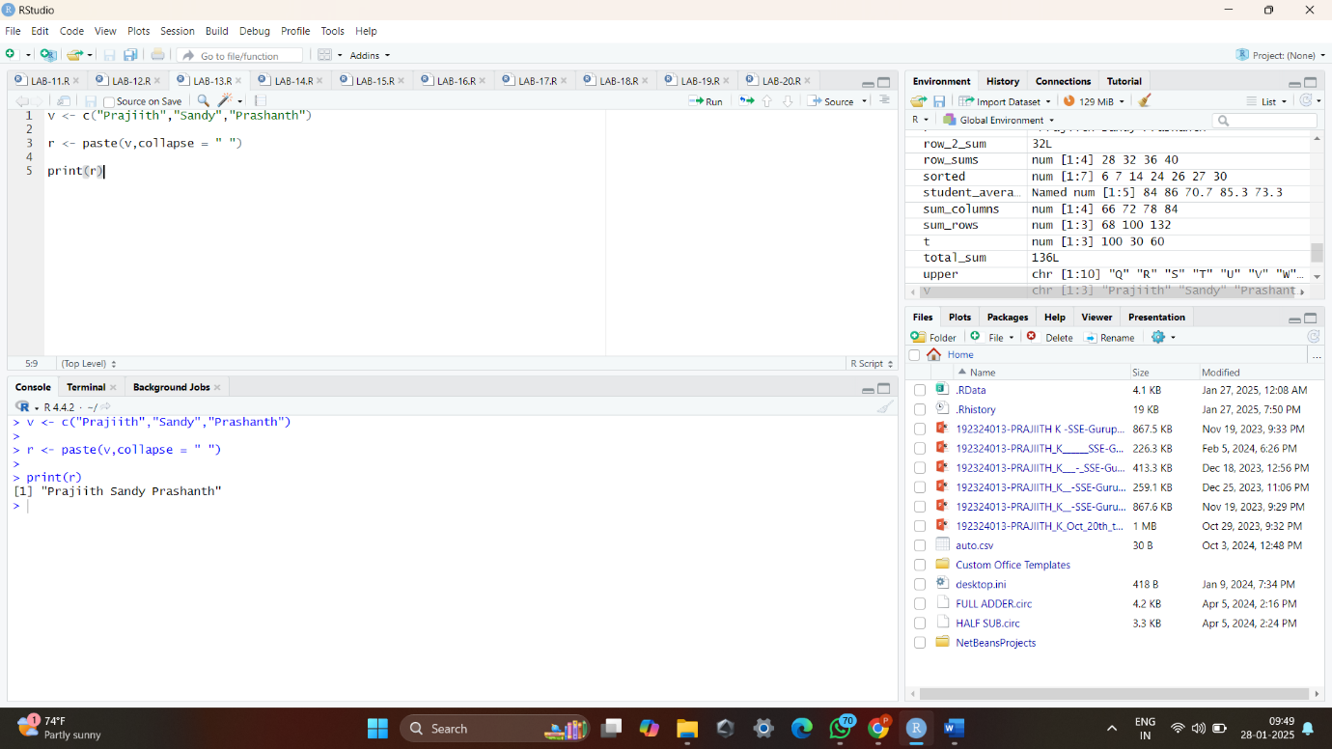

14. Write an R program to Find the row and column index of maximum and minimum value in a matrix in R.

**PROGRAM CODE**:

matrix_data <- matrix(c(10,30,200,90,100,70,60,150,1), nrow = 3, byrow = TRUE)

print("Matrix:")

print(matrix_data)

max_value <- max(matrix_data)

max_index <- which(matrix_data == max_value, arr.ind = TRUE)

cat("Maximum Value:", max_value, "\n")

cat("Row and column index of max value:", max_index, "\n")

min_value <- min(matrix_data)

min_index <- which(matrix_data == min_value, arr.ind = TRUE)

cat("Minimum Value:", min_value, "\n")

cat("Row and column index of max value:", max_index, "\n")

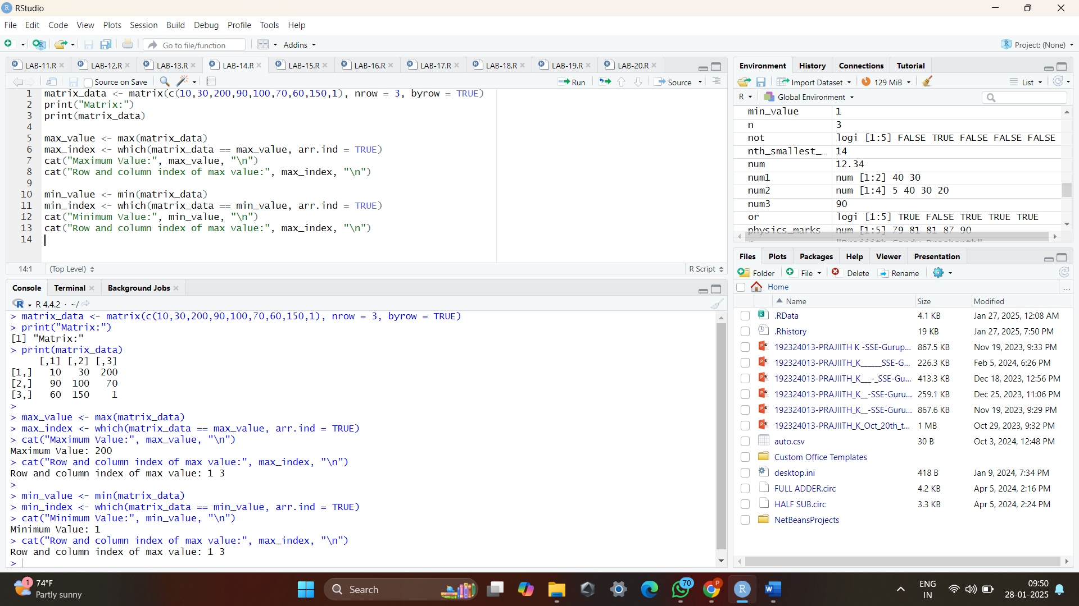

15. Write an R program to print the numbers from 1 to 100 and print "Fizz" for multiples of 3, print "Buzz" for multiples of 5, and print "FizzBuzz" for multiples of both.

**PROGRAM CODE**:

for(i in 1:100){

if(i%%3==0 & i%%5==0){

print("FizzBuzz")

}

else if(i%%3==0){

print("Fizz")

}

else if(i%%5==0){

print("Buzz")

}

else{

print(i)

}

}

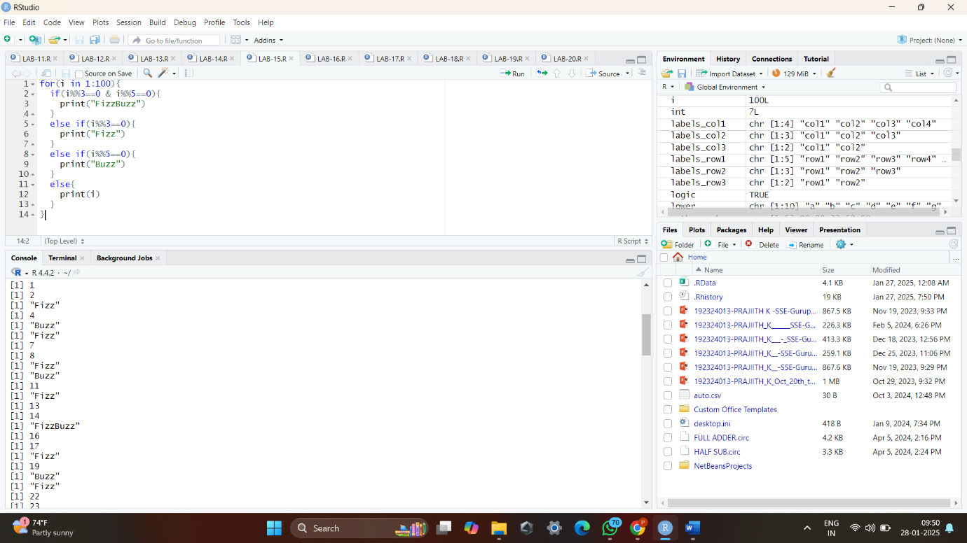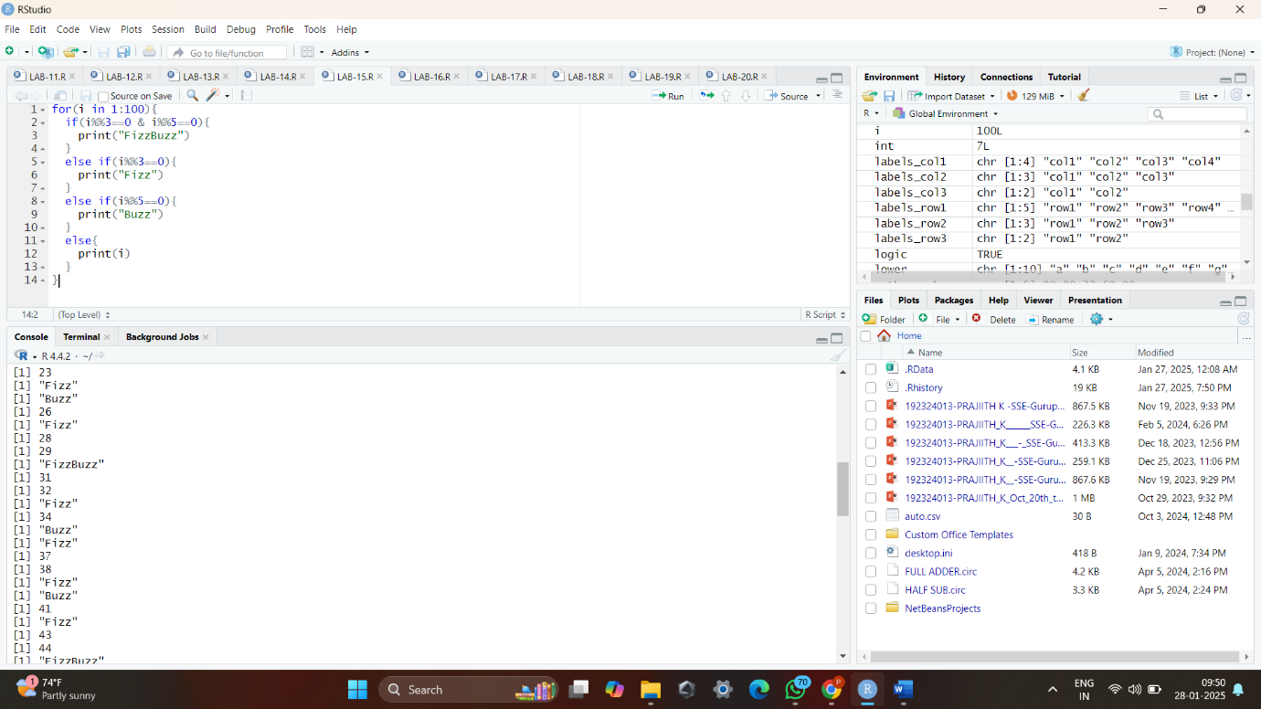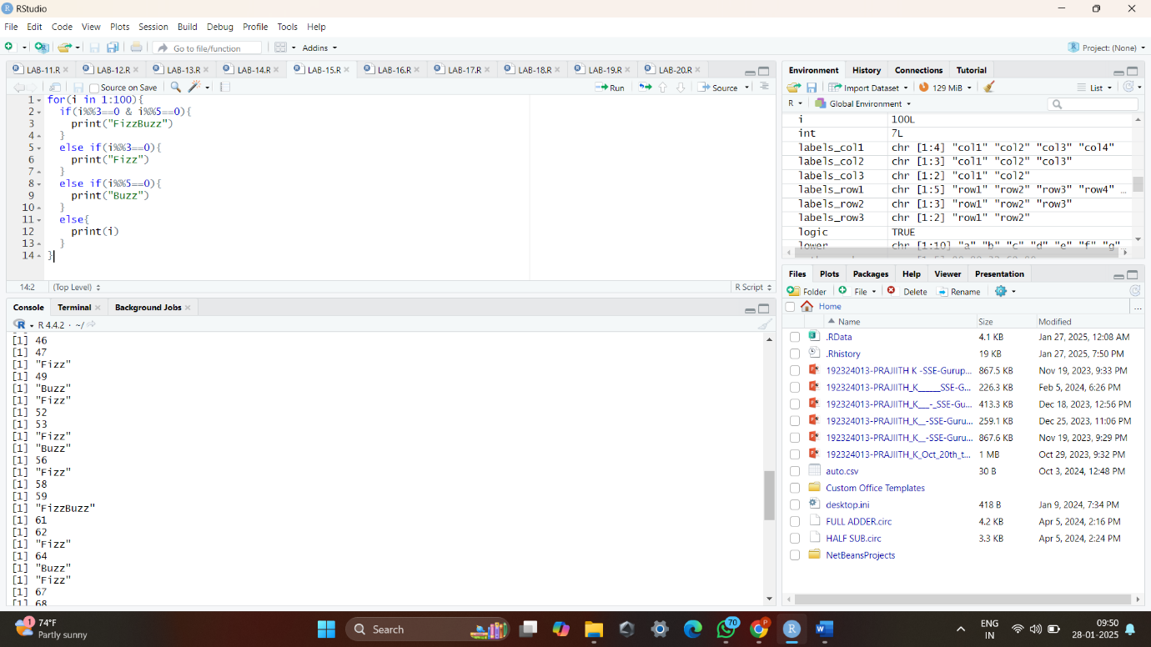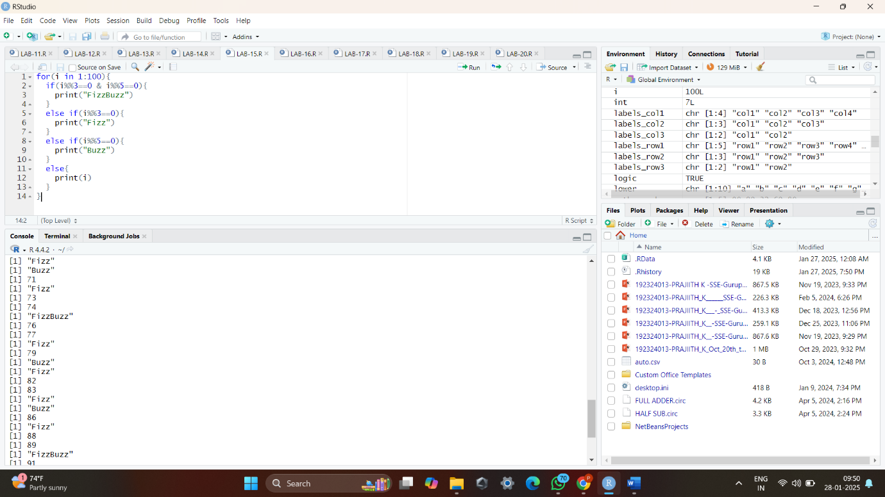

16. Write an R program to convert the list to a data frame with specific column names in R.

**PROGRAM CODE**:

l <- list(

ID = c(101, 102, 103),

Name = c("Prajiith", "Santhosh", "Prashanth"),

Age = c(19,20,19)

)

frame<- as.data.frame(l)

print(frame)

class(frame)

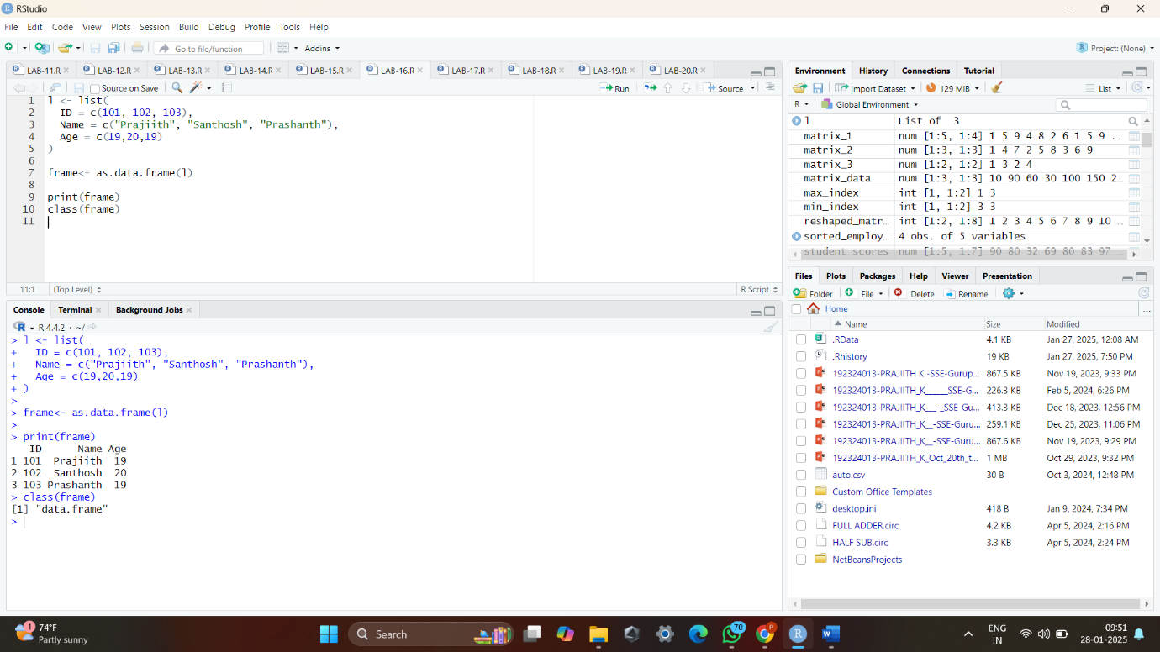

17. Write an R program to create a Data Frames that contain details of 5 employees and display a summary of the data.

**PROGRAM CODE**:

employee_details <- data.frame(id=c(1,2,3,4,5),

name=c("Prajiith","Sandy","Prashanth","Mano","Deenesh"),

age=c(18L,19L,18L,18,18),

salary=c(100000.80,80000,90000,75000,79000))

print("Employee Details\n")

print(employee_details)

print("\nSummary of Employee Details")

summary(employee_details)

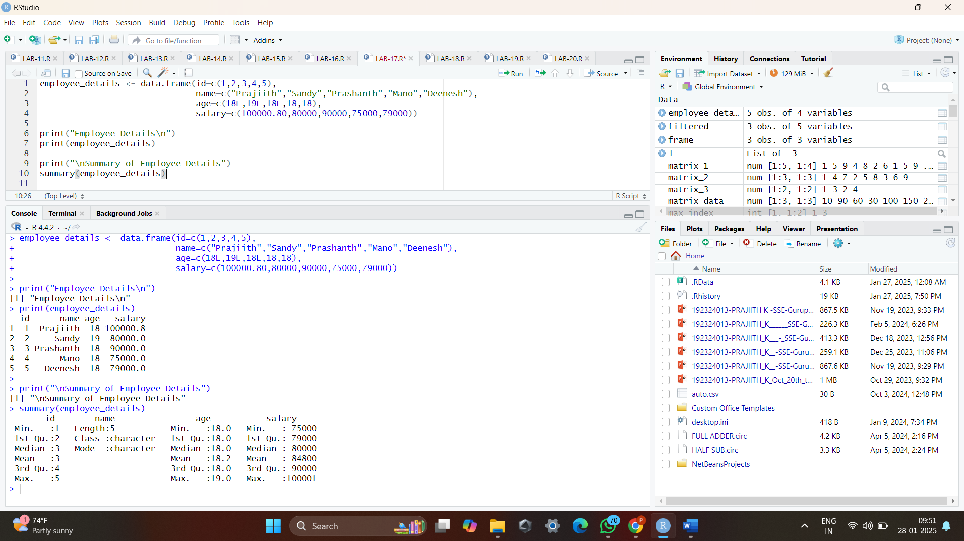

18. Write an R program to find the maximum and the minimum value of a given vector.

**PROGRAM CODE**:

v <- c(43,57,29,10,72,90)

cat("Maximum number in the vector:",max(v),"\n")

cat("Minimum number in the vector:",min(v))

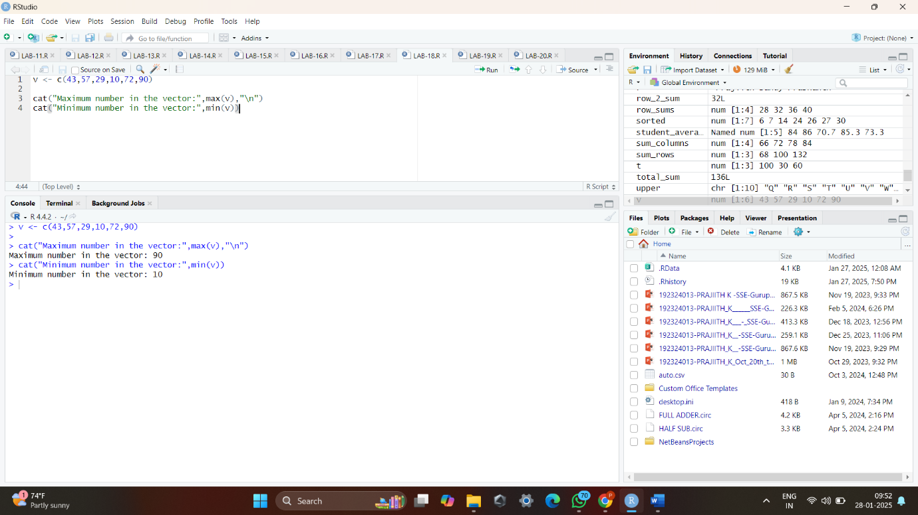

19. Write an R program to create an array with three columns, three rows, and two "tables", taking two vectors as input to the array. Print the array.

**PROGRAM CODE**:

v1 <- c(1, 2, 3, 4, 5, 6)

v2 <- c(7, 8, 9, 10, 11, 12)

v3<- c(v1,v2)

array <- array(v3, dim = c(3, 3, 2))

print("The created array is:")

print(array)

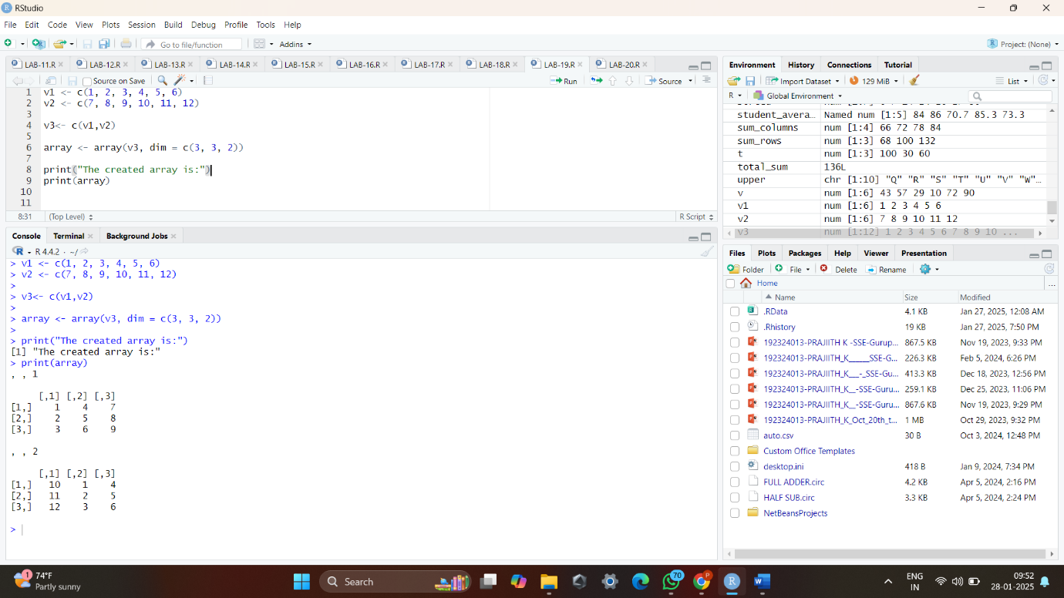

20. Write an R program to assign grades based on a student’s score using an if-else statement.

**PROGRAM CODE**:

score <- 78

if (score >= 90) {

grade <- "S"

} else if(score >= 80) {

grade <- "A"

} else if (score >= 70) {

grade <- "B"

} else if (score >= 60) {

grade <- "C"

} else if (score >= 50) {

grade <- "D"

}else{

grade <- "E"

}

cat("Score:", score, "\nGrade:", grade, "\n")

